**Exp. STUDY OF ARM PROCESSOR**

**Date:**

**Aim:**

To study the architecture and working of an ARM processor.

**Component Required:**

* ARM LPC2148

**Theory:**

ARM is a family of instruction set architectures for computer processors based on a reduced instruction set computing (RISC) architecture developed by British company ARM Holdings. A RISC-based computer design approach means ARM processors require significantly fewer transistors than typical processors in average computers. This approach reduces costs, heat and power use. These are desirable traits for light, portable, battery-powered devices—including smartphones, laptops, tablet and notepad computers), and other embedded systems. A simpler design facilitates more efficient multi-core CPUs and higher core counts at lower cost, providing higher processing power and improved energy efficiency for servers and supercomputers.

**Features of LPC214x Series Controllers:**

* 8 to 40 kB of on-chip static RAM and 32 to 512 kB of on-chip flash program memory.128 bit wide interface/accelerator enables high speed 60 MHz operation.
* In-System/In-Application Programming (ISP/IAP) via on-chip boot-loader software. Single flash sector or full chip erase in 400 ms and programming of 256 bytes in 1ms.
* Embedded ICE RT and Embedded Trace interfaces offer real-time debugging with the on-chip Real Monitor software and high speed tracing of instruction execution.
* USB 2.0 Full Speed compliant Device Controller with 2 kB of endpoint RAM. In addition, the LPC2146/8 provides 8 kB of on-chip RAM accessible to USB by DMA.
* One or two (LPC2141/2 vs. LPC2144/6/8) 10-bit A/D converters provide a total of 6/14analog inputs, with conversion times as low as 2.44 us per channel.
* Single 10-bit D/A converter provides variable analog output.
* Two 32-bit timers/external event counters (with four capture and four compare channels each), PWM unit (six outputs) and watchdog.
* Low power real-time clock with independent power and dedicated 32 kHz clock input.
* Multiple serial interfaces including two UARTs (16C550), two Fast I2C-bus (400 kbit/s), SPI and SSP with buffering and variable data length capabilities.
* Vectored interrupt controller with configurable priorities and vector addresses.
* Up to 45 of 5 V tolerant fast general purpose I/O pins in a tiny LQFP64 package.
* Up to nine edge or level sensitive external interrupt pins available.
* On-chip integrated oscillator operates with an external crystal in range from 1 MHz to30 MHz and with an external oscillator up to 50 MHz.
* Power saving modes include Idle and Power-down.
* Individual enable/disable of peripheral functions as well as peripheral clock scaling for additional power optimization.
* Processor wake-up from Power-down mode via external interrupt, USB, Brown-Out Detect (BOD) or Real-Time Clock (RTC).
* Single power supply chip with Power-On Reset (POR) and BOD circuits – CPU operating voltage range of 3.0 V to 3.6 V (3.3 V ± 10 %) with 5 V tolerant I/O pads.

LPC2148 needs the following hardware to work properly:

* Power Supply
* Crystal Oscillator
* Reset Circuit
* RTC crystal oscillator
* UART

*Power Supply*

LPC2148 works on 3.3 V power supply. LM 117 can be used for generating 3.3 V supply. However, basic peripherals like LCD, ULN 2003 (Motor Driver IC) etc. works on 5V. So AC mains supply is converted into 5V using below mentioned circuit and after that LM 117 is used to convert 5V into 3.3V.

*Reset Circuit*

Reset button is essential in a system to avoid programming pitfalls and sometimes to manually bring back the system to the initialization mode. MCP 130T is a special IC used for providing stable RESET signal to LPC 2148.

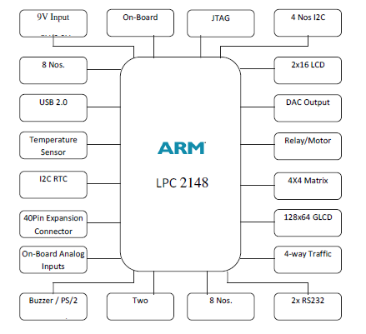

**Figure - 3.1:** ARM Processor

*Flash Programming Utility*

NXP Semiconductors produce a range of Microcontrollers that feature both on-chip. Flash memory and the ability to be reprogrammed using In-System Programming technology.

**On-board Peripherals**

• 8-Nos. of Point LED’s (Digital Outputs)

• 8-Nos. of Digital Inputs (Slide Switch)

• 2 Lines X 16 Character LCD Display

• I2C Enabled 4 Digit Seven-Segment Display

• 128x64 Graphical LCD Display

• 4 X 4 Matrix keypad

• Stepper Motor Interface

• 2 Nos. Relay Interface

• Two UART for Serial Port Communication through PC

• Serial EEPROM

• On-chip Real Time Clock with Battery Backup

• PS/2 Keyboard Interface (Optional)

• Temperature Sensor

• Buzzer (Alarm Interface)

• Traffic Light Module (Optional)

**Pin Configuration**

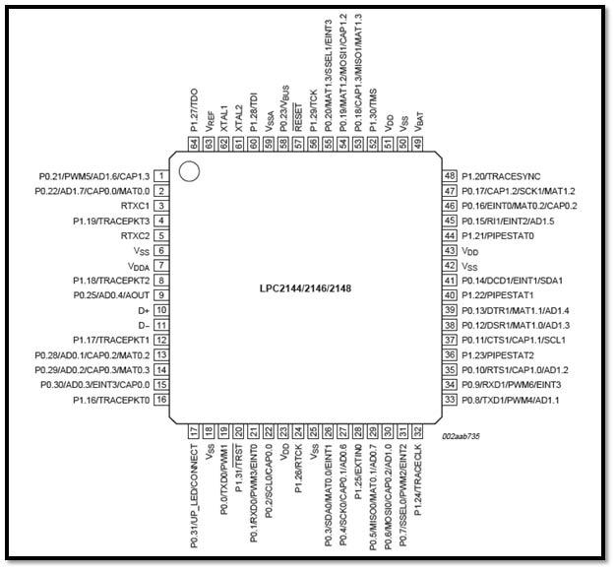

**Result:**

The ARM processor has been studied successfully.

**Exp.**

**Write and execute C program to blink LEDs using software delay routine in LPC2148 kit**

**Date:**

**Aim:** To write and execute a C program to blink LEDs using software delay routine in LPC 2148 kit

**Apparatus Required:**

Keil uVision5 Software

Philips Flah Programmer

LPC 2148 kit

**Program:**

#include "lpc214x.h"

void delay (unsigned int k);

void main(void)

{

IODIR0 = 0xFFFFFFFF; //Configure Port0 as output Port

PINSEL0 = 0; //Configure Port0 as General Purose IO

while(1)

{

IOSET0 = 0x0000ff00; //Set P0.15-P0.8 to '1'

delay(1000); //1 sec Delay

IOCLR0 = 0x0000ff00; //Set P0.15-P0.8 to '0'

delay(1000); //1 Sec Delay

}

}

//Delay Program

//Input - delay value in milli seconds

void delay(unsigned int k)

{

unsigned int i,j;

for (j=0; j<k; j++)

for(i = 0; i<=800; i++);

**Output:** LEDs P0.15-P0.8 are blinking

**Result:**

Thus the C program to blink LEDs using software delay routine was written and executed in LPC 2148 kit

**Exp.**

**Write and execute C program to read the switch and display in the LEDs using LPC2148 kit**

**Date:**

**Aim:**  To write and execute C program to read the switch and display in the LEDs using LPC2148 kit

**Apparatus Required:**

Keil uVision5 Software

Philips Flah Programmer

LPC 2148 kit

**Program:**

#include "lpc214x.h"

int main(void)

{

unsigned int sw_sts;

IODIR0 = 0x0000ff00; //Configure Port0

PINSEL0 = 0; //Configure Port0 as General Purose IO

while(1)

{

sw_sts = IOPIN0;

IOSET0 = 0x0000ff00; //Set P0.15-P0.8 to '1'

IOCLR0 = sw_sts >> 8; //Set P0.15-P0.8 to '0'

}

}

Output: LEDs P0.15-P0.08 displayed the bits entered in the switches

Result:

Thus C program was written read the switch and display in the LEDs using LPC2148 kit

**Exp.**

**Write and execute C program to display a number in seven segment LED in LPC2148 kit**

**Date:**

**Aim:** To write and execute C program to display a number in seven segment LED in LPC2148 kit

**Apparatus Required:**

Keil uVision5 Software

Philips Flah Programmer

LPC 2148 kit

**Program:**

//SEVEN SEGMENT LED DISPLAY INTERFACE IN C

/* Program to Count 0-9 and Display it in 7 segment Display (MUX) DS4

* Display Select DS3 ==> "P0.13" Enable --> '0', Disable --> '1'

* Display Select DS4 ==> "P0.12" Enable --> '0', Disable --> '1'

*/

/* Segment Connection Display 1 & 2 Enable --> '1', Disable --> '0'

*--------------------------------------------------------------------

* MSB LSB

* Dp G F E D C B A

* P0.23 P0.22 P0.21 P0.20 P0.19 P0.18 P0.17 P0.16

* 0 0 0 0 0 1 1 0 --> 6 => '1'

*---------------------------------------------------------------------*/

#include <LPC214X.H>

#define DS3 1<<13 // P0.13

#define DS4 1<<12 // P0.12

#define SEG_CODE 0xFF<<16 // Segment Data from P0.16 to P0.23

unsigned char const seg_dat[]={0x3F, 0x6, 0x5B, 0x4F, 0x66, 0x6D, 0x7D, 0x7, 0x7F, 0x67};

void delayms(int n)

{

int i,j;

for(i=0;i<n;i++)

{for(j=0;j<5035;j++) //5035 for 60Mhz ** 1007 for 12Mhz

{;}

}

}

int main (void)

{

unsigned char count;

PINSEL0 = 0; // Configure Port0 as General Purpose IO => P0.0 to P0.15

PINSEL1 = 0; // Configure Port0 as General Purpose IO => P0.16 to P0.31

IODIR0 = SEG_CODE | DS3 | DS4; //Configure Segement data & Select signal as output

IOSET0 = SEG_CODE | DS3 ; //Disable DS3 display

IOCLR0 = DS4; //Enable DS4 Display

count = 0; //Initialize Count

//Display Count value

IOCLR0 = SEG_CODE;

IOSET0 = seg_dat[count]<<16;

while(1)

{

delayms(1000); //1 sec delay

count++; //Increment count

if(count>9) count=0; //Limit 0-9

//Display Count value

IOCLR0 = SEG_CODE;

IOSET0 = seg_dat[count]<<16;

}

}

**Output:** 7-Segment display counting from 0 to 9

**Result:**

Thus C program, was written and executed to display a number in seven segment LED in LPC2148 kit

**Exp.**

**Write and execute C program for serial transmission and reception using on-chip UART in LPC2148 kit.**

**Date:**

**Aim:** To write and execute C program for serial transmission and reception using on-chip UART in LPC2148 kit.

**Apparatus Required:**

Keil uVision5 Software

Philips Flah Programmer

LPC 2148 kit

**Program:**

#include <lpc214x.h>

void UART0_Init(void)

{

PLL0CON = 0;

PLL0FEED=0xAA;

PLL0FEED=0x55;

VPBDIV = 1;

// Fpclk = 12.000.000 MHz

// DLM,DLH = Fpclk / (19200*16) = 39 = 0x27

PINSEL0 |= 0x5; // Select UART0 RXD/TXD

U0FCR = 0; // Disable FIFO's

U0LCR = 0x83; // 8N1, enable Divisor latch bit

U0DLL = 0x27; // baud rate fixed to 19200 @ PCLK = 12 Mhz

U0DLM = 0;

U0LCR = 3; // Disable Divisor latch bit

}

/*------------------------------------------------------------------*/

/* Function to send one char. to Serial Port */

void sout(unsigned char dat1)

{

while(!(U0LSR & 0x20));//Wait for Tx Buffer Empty

U0THR = dat1; //Send to UART1

}

/*-------------------------------------------------------*/

int main (void)

{ int dat;

UART0_Init();

do

{

if(U0LSR & 1) /* Check for RDR (Receiver Data Ready)command */

{

dat = U0RBR;// Receive Data from Srial Port

sout(dat); // Send Data to Srial Port

}

}while(1);

}

**Output:** Data was serially transmitted

**Result:**

Thus a C program was Written and executed for serial transmission and reception using on-chip UART in LPC2148 kit.

**Exp.**

**Write and execute C program for accessing an internal ADC and display the binary output in LEDS in LPC2148 kit**

**Date:**

**Aim:** To write and execute C program for accessing an internal ADC and display the binary output in LEDS in LPC2148 kit.

**Apparatus Required:**

Keil uVision5 Software

Philips Flah Programmer

LPC 2148 kit

**Program:**

#include <LPC214X.H>

#define LEDS 0xFF<<8 //LED => P0.8 to P0.15

/////////////////////////////////////////

/*--- ADC Signal Declaration */

/////////////////////////////////////////

#define AD0_1 1<< 24

#define CLK_DIV 1<<8

#define PDN 1<<21

#define SOC 1<<24

#define BURST 1<<16

#define DONE 1<<31

/*-----------------------------------------------------------*/

//Delay Program

//Input - delay value in milli seconds

void delay(unsigned int k)

{

unsigned int i,j;

for (j=0; j<k; j++)

for(i = 0; i<=800; i++);

}

/*-----------------------------------------------------------*/

void adc_init()

{

unsigned long int ADC_CH;

ADC_CH = 0 | 1 << 1; //Channel AD0.1

AD0CR = SOC | PDN | CLK_DIV | ADC_CH | BURST ;

}

/*-----------------------------------------------------------*/

unsigned int adc_read( unsigned char channel)

{

unsigned int aval;

unsigned long int val;

if (channel == 1) val = AD0DR1;

else if (channel == 2) val = AD0DR2;

else if (channel == 3) val = AD0DR3;

val = val >> 6;

val = val & 0x3FF;

aval = val;

return (aval);

}

/*-----------------------------------------------------------*/

//////////////////////////

/*----Main Program------*/

//////////////////////////

int main(void)

{

unsigned int tp1;

IODIR0 = LEDS; //Configure Port0 as output Port

PINSEL0 = 0; //Configure Port0 as General Purpose IO

PINSEL1 = 0 | AD0_1; // Enable AD0.1

adc_init(); //Initialise on-chip ADC

do

{ tp1 = adc_read(1); // Channel AD0 0.1

tp1 = tp1 >> 2; // ADC 10 bit But LED 8bit, Truncate lsb 2 bits

IOSET0 = LEDS; //Switch OFF all LEDS

IOCLR0 = tp1 << 8; //Set VAlue

delay(1000);

}while(1);

}

**Output:** The Potentiometer knob was adjusted to generate Analog input and Digital display is observed

**Result:**

Thus C program was Written and executed for accessing an internal ADC and display the binary output in LEDS in LPC2148 kit.